

**PROJECT PROPOSAL**

(E-Wallet and QR Code Purchase Platform)

Practice Module for Certificate in Securing Ubiquitous Systems

**Team 2**

Team Members:

Xu Jiao (E0384412)

Zou Xuan (E0384799)

**PRIVATE & CONFIDENTIAL**

*Content of this document is provided as part of project stated above, and may not   
be used, reproduced or distributed except for the sole purpose of that project.*

Document History

|  |  |  |
| --- | --- | --- |
| **Version** | **Date** | **Comments** |
| 0.1 | 21 Jul 2019 | Draft |
| 0.2 | 23 Jul 2019 | Update |
| 0.3 | 25 Jul 2019 | Update |
| 0.4 | 28 Jul 2019 | Update |
| 1.0 | 28 Jul 2019 | V1 Final |
| 1.1 | 8 Aug 2019 | V2 Final |

Document Usage

This document is confidential to the client to whom it is presented, and is not intended for public use. It must not be reproduced or transmitted in any form or by any means, in whole or in part, without the express permission of the document owner.

The functional and design specifications contained herein summarise the features of the proposed system and the deliverables from document owner to the client under the system.

1. Table of Contents

1 Overview 4

2 Current application analysis 4

3 Scope of Work 6

4 Effort Estimates 6

# 1 Overview

A fruits vending machine company would like to establish a membership system to public customers. With this platform, public customers will be able to register as a member and top-up e-wallet, purchase QR code with e-wallet balance. The company will be able to recognize their customers and improve the quality of their service based the customer data/feedback that they will get from this platform. This requires exposing its existing internal services to the internet, the creation of suitable web-based and mobile client applications. The security architecture of the platform has to be analyzed, designed and reviewed to ensure that systems, data, network and other infrastructure of the platform are adequately protected.

# 2 Current application analyses

**2.1 Current project architecture**

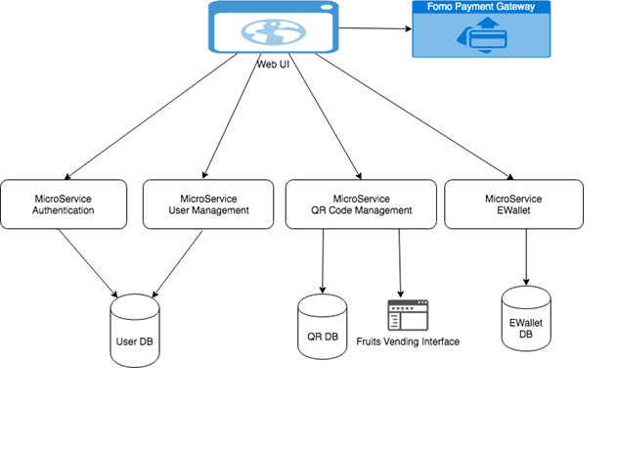

It is based on the last term project which have web application on microservices architecture on cloud. Currently we going to add hybrid mobile application and other security functions into this project.

**2.2 Security issue to be solved**

1) User Management

a. User Management only has simple register function, will implement 2FA to help address the vulnerabilities of a standard password only approach. With 2FA implemented, the “Forgot Password” can be added to provide better user experience.

b. User Management is not protected by any token. Even though there was no user token during registering stage, this API can still be protected by client credential token.

2) Authentication and Authorization

a. Auth service is following OAuth2 password grant type. But currently is directly connecting User DB, which makes User DB has to open a firewall to Auth Service. This puts user data in risk if auth service is not handling data properly. Consider provide an API in user management service to validate user name and password, Auth service will call this API to validate user instead of directly connecting to DB.

b. Lack of OpenID Connect identity layer on top of the OAuth 2.0 protocol.

c. Hard coded one client credential, so that “Fruits Vending Interface” and Web UI is using sharing same clientId. To solve this issue, there should be a configurable place to maintain different clientId and scope to constrain the usage of token be only applied to specific endpoint.

d. The token issued does not include user’s role info. Will implement the role based access control for different type of user.

e. No revoke and refresh access token catered.

3) E-Wallet &QR

User info is read from payload of the request instead of from the JWT token. Which can cause the risk of exposing other user’s info. To solve this issue, the E-Wallet/QR should get user info from the token, so it only returns data for that specific user.

4) Communication

Encryption mechanism on the access token and payload while passing between services. The encryption key can be generated per session. Using HTTPS (LTS 1.2) for service communication.

**2.3 Threat modelling**



Based on the threat modelling of hybrid mobile apps and web applications.

We going to add security controls like:

1. User authentication /Authorization (upgrade authentication service)
2. Data encryption (application data, user private data and authentication token/user credentials)
3. App store verification
4. Java script obfuscation (both mobile and web code)
5. Whitelist of sites accessible through webview(trim access down to only those URIs that actually need to use in the app)

# 3 Scope of Work

1. Solve all the security issues addressed in part 2.
2. Add one product management page for admin
3. Use Web Component to rewrite Web UI
4. Add hybrid mobile application using ionic + cordova.
5. Add email notification and protect sensitive information by end to end encryption.
6. Add penetration test.

# 4 Effort Estimates

|  |  |
| --- | --- |
| Task | Efforts |
| 2FA in user management service | 2 day |
| Forget password in user management service | 1 day |
| Login user validation API in user management service | 1 day |
| Protect user management service by token | 0.5 day |
| Client credential management in Auth service | 0.5 day |
| Read user info from token instead of payload in E-Wallet & QR service | 0.5 day |
| Validate Fruits vending clientId token in QR service | 0.5 day |
| Add product management API / role segregation in QR Service | 1 day |
| Build web components | 3 days |
| integrate Mobile UI and Web UI with web components | 5 days |
| Add data encryption method/TLS2.0/http redirect to https | 1 day |
| Encrypt access token by session | 1 day |
| Implement email notification and add end to end encryption | 2 days |
| Deploy app to Google play store | 0.5 day |